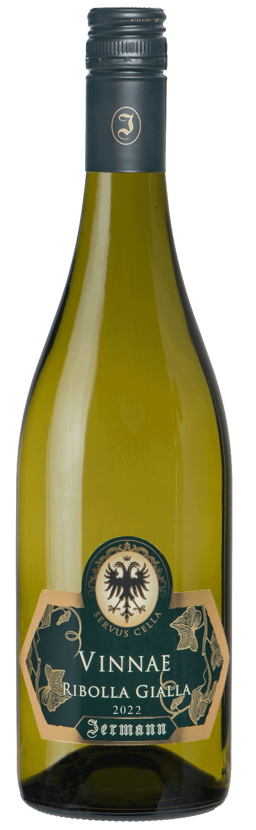
Factsheet of Vinnae Ribolla Gialla

Type of soil: originated from the Eocene elevation, which determined the spread of an extended zone of colluvial material around it, and marl with sandstone belonging to the “flyschoide” period that have given rise to a rocky substratum.

Grape varieties: mainly Ribolla Gialla
Vineyard Sites: East/south
Alcohol content: 12.5% Acidity: 5.7 - 6.30 ‰
First vintage: 1983
Denomination: IGT Venezia Giulia
Harvest time: September
Shelf life: 4-6 years

It’s also available with Stelvin screw cap by the French company Pechiney: we decided for this very technical closure to preserve the fragrance and the organoleptic qualities obtained first in the vineyard and then in the cellar.
Tasting notes: It has a bright, pale straw shade and fruit aromas with a mineral undertone. On the palate it is dry, fresh and tangy with the unassuming elegance of an authentic country wine. Vinnae is delicious as an aperitif and it is also an excellent match for seafood starters and first course dishes with fish. Its freshness and irresistible drinkability make it an ideal summer white.
History: The name Vinnae was created for the 1983 vintage to celebrate the birth of Silvio Jermann’s second son and to commemorate the Jermann family’s 100 years of winemaking at Villanova. Five generations of the family have cultivated Ribolla in the Collio vineyards of the village, earning themselves the title of “vinnaioli” or “wine growers”; hence the choice of the name “Vinnae” of this Ribolla-based wine
The label was restyled in 2004 with the addition of a symbol of the Jermann family’s Austrio-Hungarian origins, a double-headed eagle found on an old barrel belonging to Silvio Jermann’s great grandfather Anton. The phrase “Servus Cella” is the winery's greeting.

